Figure 6
Connections over 200 kbps in at Least One Direction 2012-2016
(In thousands)

 | 2012 |  | 2013 |  | 2014 |  | 2015 |  | 2016
Technology | Jun | Dec | Jun | Dec | Jun* | Dec | Jun | Dec | Jun
Total | 243,359 | 262,564 | 284,692 | 293,397 | 311,284 | 321,305 | 342,096 | 355,229 | 369,416
Total Fixed | 89,945 | 92,511 | 93,986 | 96,032 | 95,998 | 97,810 | 100,134 | 102,212 | 104,042
Mobile Wireless | 153,414 | 170,053 | 190,706 | 197,365 | 215,286 | 223,495 | 241,962 | 253,017 | 265,374

Figure 7
Residential Connections over 200 kbps in at Least One Direction 2012-2016
(In thousands)

 | 2012 |  | 2013 |  | 2014 |  | 2015 |  | 2016
Technology | Jun | Dec | Jun | Dec | Jun* | Dec | Jun | Dec | Jun
Total | 196,665 | 215,817 | 235,273 | 246,797 | 264,343 | 273,950 | 292,279 | 303,655 | 316,454
Total Fixed | 82,217 | 84,392 | 85,277 | 87,599 | 87,360 | 89,196 | 91,419 | 93,430 | 94,966
Mobile Wireless | 114,448 | 131,425 | 149,996 | 159,197 | 176,983 | 184,754 | 200,859 | 210,224 | 221,488

* The June 2014 data have not been subjected to the typical quality checks (see Technical Notes).

The Commission approved changes to the Form 477 in June 2013 that affect the data beginning in June 2014 (see Technical Notes). Some previously-published
data may have been revised. Figures may not sum to totals elsewhere in this report due to rounding.

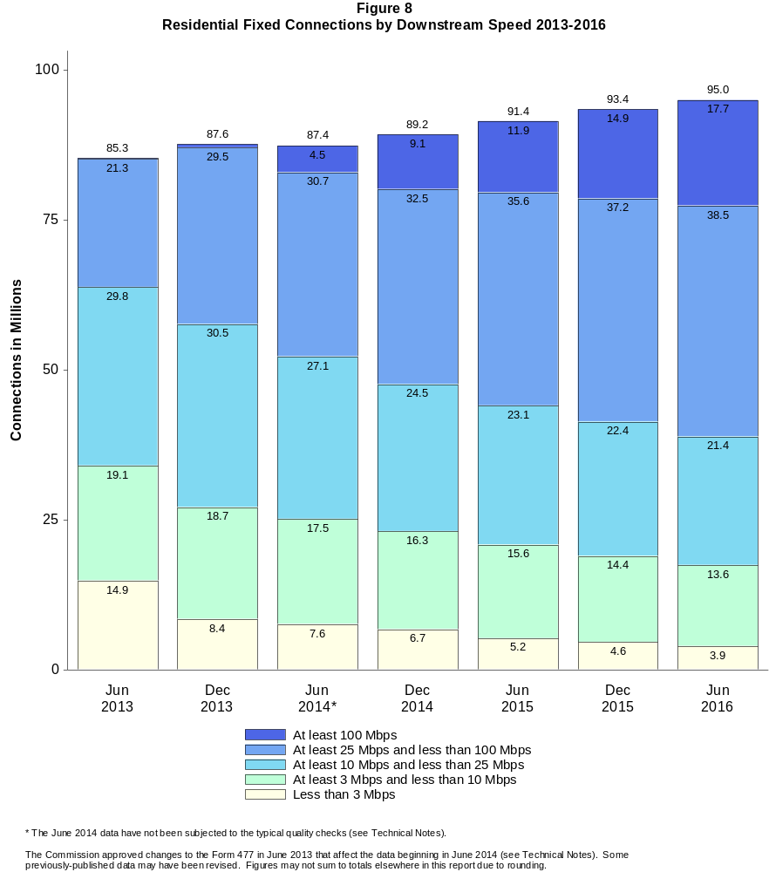

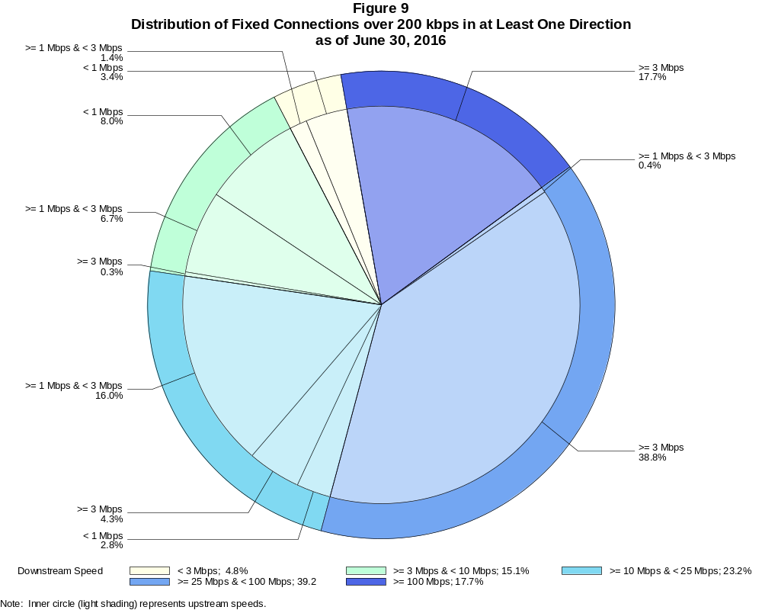

Fixed Connections over 200 kbps in at Least One Direction (in thousands)

 | Downstream Speed
Upstream Speed | Less than 3 Mbps | At least 3 Mbps  and less than 10 Mbps | At least 10 Mbps  and less than 25 Mbps | At least 25 Mbps  and less than 100 Mbps | At least 100 Mbps | Total
Less than 1 Mbps | 3,533 | 8,363 | 2,898 | 7 | 1 | 14,802
At least 1 Mbps & Less than 3 Mbps | 1,474 | 6,984 | 16,691 | 449 | 10 | 25,608
At least 3 Mbps | 1 | 346 | 4,512 | 40,350 | 18,425 | 63,633
Total | 5,008 | 15,692 | 24,101 | 40,806 | 18,435 | 104,042

Percentages

Less than 1 Mbps | 3.4 | 8.0 | 2.8 | 0.0 | 0.0 | 14.2
At least 1 Mbps & Less than 3 Mbps | 1.4 | 6.7 | 16.0 | 0.4 | 0.0 | 24.6
At least 3 Mbps | 0.0 | 0.3 | 4.3 | 38.8 | 17.7 | 61.2
Total | 4.8 | 15.1 | 23.2 | 39.2 | 17.7 | 100.0

Note: Figures may not sum to totals due to rounding. # = Rounds to zero.
Source: FCC Form 477.

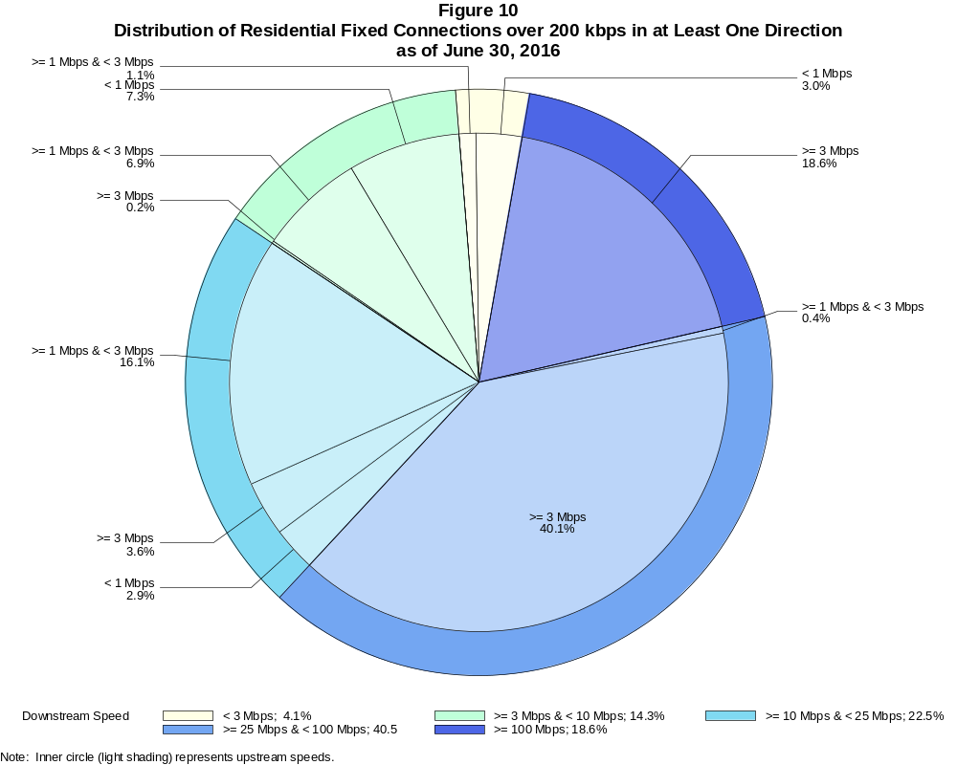

Residential Fixed Connections over 200 kbps in at Least One Direction (in thousands)

 | Downstream Speed
Upstream Speed | Less than 3 Mbps | At least 3 Mbps  and less than 10 Mbps | At least 10 Mbps  and less than 25 Mbps | At least 25 Mbps  and less than 100 Mbps | At least 100 Mbps | Total
Less than 1 Mbps | 2,827 | 6,906 | 2,710 | 7 | # | 12,450
At least 1 Mbps & Less than 3 Mbps | 1,028 | 6,519 | 15,307 | 411 | 5 | 23,269
At least 3 Mbps | # | 146 | 3,383 | 38,049 | 17,669 | 59,248
Total | 3,854 | 13,571 | 21,401 | 38,466 | 17,674 | 94,966

Percentages

Less than 1 Mbps | 3.0 | 7.3 | 2.9 | 0.0 | 0.0 | 13.1
At least 1 Mbps & Less than 3 Mbps | 1.1 | 6.9 | 16.1 | 0.4 | 0.0 | 24.5
At least 3 Mbps | 0.0 | 0.2 | 3.6 | 40.1 | 18.6 | 62.4
Total | 4.1 | 14.3 | 22.5 | 40.5 | 18.6 | 100.0

Note: Figures may not sum to totals due to rounding. # = Rounds to zero.
Source: FCC Form 477.

Figure 11
Connections over 200 kbps in at Least One Direction by Technology 2012-2016
(In thousands)

 | 2012 |  | 2013 |  | 2014 |  | 2015 |  | 2016
Technology | Jun | Dec | Jun | Dec | Jun* | Dec | Jun | Dec | Jun
Total | 243,359 | 262,564 | 284,692 | 293,397 | 311,284 | 321,305 | 342,096 | 355,229 | 369,416
Total Fixed | 89,945 | 92,511 | 93,986 | 96,032 | 95,998 | 97,810 | 100,134 | 102,212 | 104,042
aDSL | 31,173 | 30,974 | 30,657 | 30,690 | 29,873 | 28,527 | 29,341 | 28,131 | 27,484
sDSL | 139 | 132 | 117 | 108 | 96 | 85 | 75 | 60 | 56
Other Wireline¹ | 770 | 796 | 769 | 772 | 792 | 723 | 682 | 693 | 673
Cable Modem | 49,664 | 51,646 | 52,760 | 54,009 | 54,011 | 56,301 | 57,243 | 59,706 | 61,453
FTTP² | 6,300 | 6,733 | 7,250 | 7,745 | 8,326 | 9,180 | 9,687 | 10,499 | 11,129
Satellite | 1,217 | 1,454 | 1,623 | 1,849 | 1,964 | 2,006 | 2,058 | 2,071 | 2,079
Fixed Wireless | 682 | 777 | 810 | 858 | 935 | 988 | 1,049 | 1,052 | 1,169
Mobile Wireless | 153,414 | 170,053 | 190,706 | 197,365 | 215,286 | 223,495 | 241,962 | 253,017 | 265,374

¹ Power Line and Other are summarized with Other Wireline to maintain firm confidentiality. See Technical Notes at the end of the report for a description of
Form 477 technology categories and other reporting requirements.
² Fiber to the premises.
* The June 2014 data have not been subjected to the typical quality checks (see Technical Notes).

The Commission approved changes to the Form 477 in June 2013 that affect the data beginning in June 2014 (see Technical Notes). Some previously-published
data may have been revised. Figures may not sum to totals due to rounding.

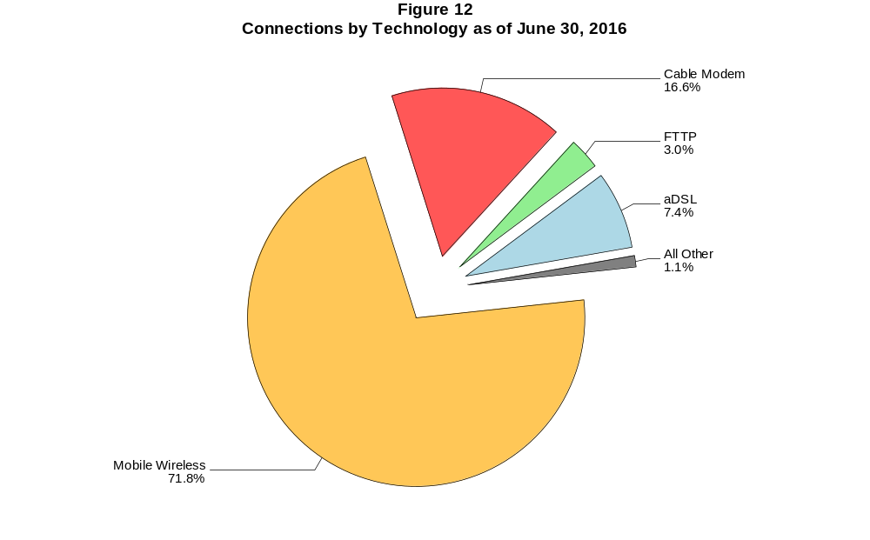

Figure 13
Residential Connections over 200 kbps in at Least One Direction by Technology 2012-2016
(In thousands)

 | 2012 |  | 2013 |  | 2014 |  | 2015 |  | 2016
Technology | Jun | Dec | Jun | Dec | Jun* | Dec | Jun | Dec | Jun
Total | 196,665 | 215,817 | 235,273 | 246,797 | 264,343 | 273,950 | 292,279 | 303,655 | 316,454
Total Fixed | 82,217 | 84,392 | 85,277 | 87,599 | 87,360 | 89,196 | 91,419 | 93,430 | 94,966
aDSL | 27,632 | 27,391 | 26,869 | 27,248 | 26,678 | 25,603 | 26,154 | 25,137 | 24,483
sDSL | 49 | 50 | 43 | 39 | 30 | 22 | 17 | 16 | 11
Other Wireline¹ | 14 | 34 | 22 | 22 | 57 | 59 | 52 | 54 | 51
Cable Modem | 47,033 | 48,716 | 49,494 | 50,709 | 50,389 | 52,467 | 53,543 | 55,799 | 57,354
FTTP² | 5,892 | 6,270 | 6,732 | 7,176 | 7,617 | 8,368 | 8,841 | 9,592 | 10,131
Satellite | 998 | 1,242 | 1,407 | 1,643 | 1,760 | 1,803 | 1,875 | 1,891 | 1,897
Fixed Wireless | 600 | 689 | 710 | 763 | 829 | 874 | 937 | 942 | 1,039
Mobile Wireless | 114,448 | 131,425 | 149,996 | 159,197 | 176,983 | 184,754 | 200,859 | 210,224 | 221,488

¹ Power Line and Other are summarized with Other Wireline to maintain firm confidentiality. See Technical Notes at the end of the report for a description of
Form 477 technology categories and other reporting requirements.
² Fiber to the premises.
* The June 2014 data have not been subjected to the typical quality checks (see Technical Notes).

The Commission approved changes to the Form 477 in June 2013 that affect the data beginning in June 2014 (see Technical Notes). Some previously-published
data may have been revised. Figures may not sum to totals due to rounding.

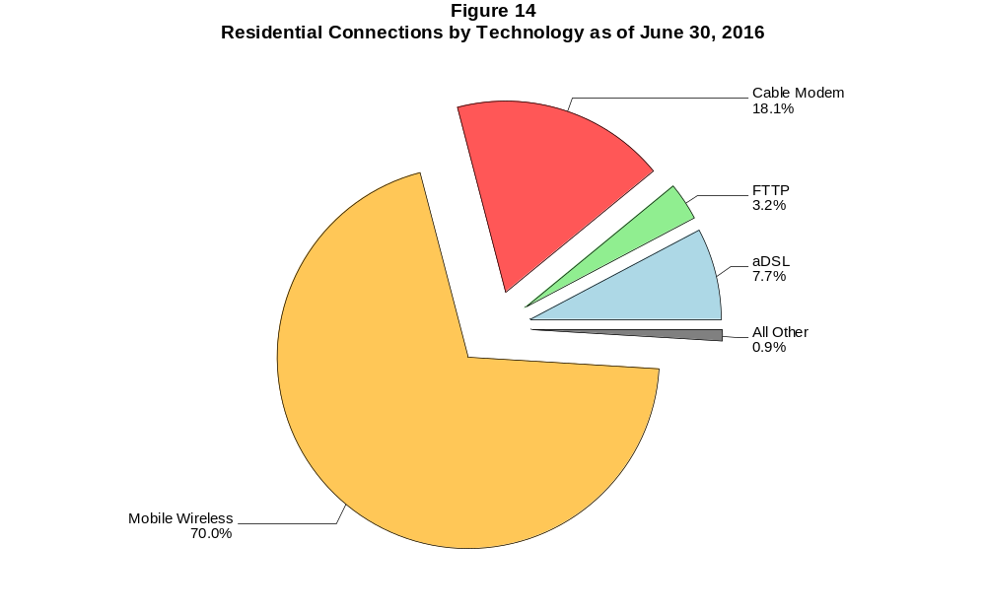

Figure 15
Fixed Connections at Least 3 Mbps Downstream and 768 kbps Upstream by Technology 2012-2016
(In thousands)

 | 2012 |  | 2013 |  | 2014 |  | 2015 |  | 2016
Technology | Jun | Dec | Jun | Dec | Jun* | Dec | Jun | Dec | Jun
Total | 57,243 | 64,657 | 68,673 | 78,175 | 78,981 | 83,872 | 88,985 | 92,352 | 95,481
aDSL | 12,875 | 13,108 | 14,233 | 18,540 | 17,246 | 18,557 | 20,939 | 20,741 | 21,144
sDSL | 30 | 33 | 34 | 36 | 33 | 28 | 24 | 20 | 20
Other Wireline¹ | 239 | 276 | 284 | 308 | 310 | 308 | 296 | 330 | 336
Cable Modem | 37,798 | 44,133 | 46,014 | 50,236 | 51,304 | 53,853 | 55,807 | 58,423 | 60,341
FTTP² | 6,001 | 6,430 | 6,981 | 7,486 | 8,111 | 8,974 | 9,551 | 10,384 | 11,017
Satellite | 87 | 394 | 791 | 1,181 | 1,424 | 1,558 | 1,690 | 1,744 | 1,775
Fixed Wireless | 214 | 284 | 337 | 388 | 553 | 594 | 677 | 710 | 849

¹ Power Line and Other are summarized with Other Wireline to maintain firm confidentiality. See Technical Notes at the end of the report for a description of Form
477 technology categories and other reporting requirements.
² Fiber to the premises.
* The June 2014 data have not been subjected to the typical quality checks (see Technical Notes).
# = Rounds to zero.

The Commission approved changes to the Form 477 in June 2013 that affect the data beginning in June 2014 (see Technical Notes). Some previously-published
data may have been revised. Figures may not sum to totals due to rounding.

Figure 16
Residential Fixed Connections at Least 3 Mbps Downstream and 768 kbps Upstream by Technology 2012-2016
(In thousands)

 | 2012 |  | 2013 |  | 2014 |  | 2015 |  | 2016
Technology | Jun | Dec | Jun | Dec | Jun* | Dec | Jun | Dec | Jun
Total | 53,070 | 59,914 | 63,342 | 72,476 | 73,042 | 77,540 | 82,300 | 85,435 | 88,170
aDSL | 11,563 | 11,669 | 12,666 | 16,715 | 15,673 | 16,867 | 18,985 | 18,863 | 19,205
sDSL | 12 | 13 | 13 | 13 | 7 | 2 | 1 | 2 | 2
Other Wireline¹ | 7 | 20 | 21 | 20 | 45 | 50 | 45 | 47 | 49
Cable Modem | 35,583 | 41,561 | 43,061 | 47,258 | 47,924 | 50,308 | 52,241 | 54,650 | 56,350
FTTP² | 5,632 | 6,012 | 6,504 | 6,958 | 7,491 | 8,246 | 8,750 | 9,513 | 10,054
Satellite | 86 | 393 | 788 | 1,177 | 1,419 | 1,552 | 1,682 | 1,734 | 1,764
Fixed Wireless | 185 | 245 | 289 | 335 | 483 | 516 | 596 | 626 | 745

¹ Power Line and Other are summarized with Other Wireline to maintain firm confidentiality. See Technical Notes at the end of the report for a description of Form
477 technology categories and other reporting requirements.
² Fiber to the premises.
* The June 2014 data have not been subjected to the typical quality checks (see Technical Notes).
# = Rounds to zero.

The Commission approved changes to the Form 477 in June 2013 that affect the data beginning in June 2014 (see Technical Notes). Some previously-published
data may have been revised. Figures may not sum to totals due to rounding.

Figure 17
Fixed Connections at Least 10 Mbps Downstream and 1 Mbps Upstream by Technology 2014-2016
(In thousands)

 | 2014 |  | 2015 |  | 2016
Technology | Jun* | Dec | Jun | Dec | Jun
Total | 63,849 | 68,009 | 72,691 | 76,939 | 80,436
aDSL | 7,573 | 8,310 | 9,463 | 9,799 | 10,348
sDSL | 9 | 6 | 8 | 8 | 8
Other Wireline¹ | 169 | 183 | 182 | 203 | 210
Cable Modem | 47,296 | 49,839 | 52,646 | 55,710 | 57,950
FTTP² | 7,615 | 8,341 | 8,873 | 9,575 | 10,130
Satellite | 1,016 | 1,137 | 1,298 | 1,393 | 1,467
Fixed Wireless | 170 | 192 | 220 | 252 | 323

¹ Power Line and Other are summarized with Other Wireline to maintain firm confidentiality. See Technical Notes at the end of the report for a description of
Form 477 technology categories and other reporting requirements.
² Fiber to the premises.
* The June 2014 data have not been subjected to the typical quality checks (see Technical Notes).
# = Rounds to zero.

The Commission approved changes to the Form 477 in June 2013 that affect the data beginning in June 2014 (see Technical Notes).
Figures may not sum to totals due to rounding.

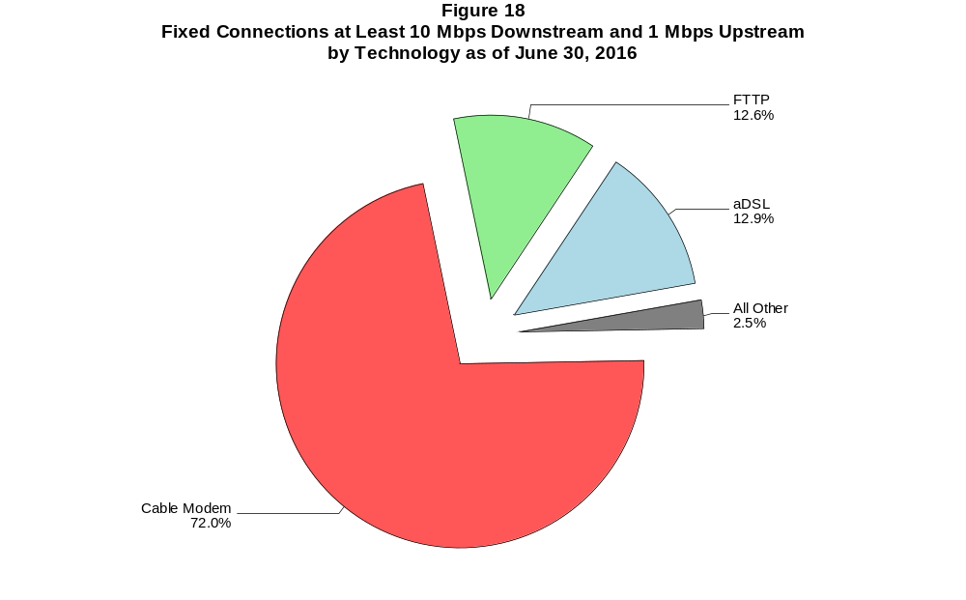

Figure 19
Residential Fixed Connections at Least 10 Mbps Downstream and 1 Mbps Upstream
by Technology 2014-2016
(In thousands)

 | 2014 |  | 2015 |  | 2016
Technology | Jun* | Dec | Jun | Dec | Jun
Total | 59,751 | 63,522 | 67,881 | 71,784 | 74,824
aDSL | 7,035 | 7,741 | 8,740 | 9,069 | 9,525
sDSL | 3 | # | # | 1 | 2
Other Wireline¹ | 33 | 36 | 38 | 43 | 47
Cable Modem | 44,480 | 46,767 | 49,475 | 52,294 | 54,273
FTTP² | 7,044 | 7,679 | 8,144 | 8,776 | 9,239
Satellite | 1,014 | 1,133 | 1,293 | 1,386 | 1,460
Fixed Wireless | 142 | 166 | 190 | 213 | 278

¹ Power Line and Other are summarized with Other Wireline to maintain firm confidentiality. See Technical Notes at the end of the report for a description of
Form 477 technology categories and other reporting requirements.
² Fiber to the premises.
* The June 2014 data have not been subjected to the typical quality checks (see Technical Notes).
# = Rounds to zero.

The Commission approved changes to the Form 477 in June 2013 that affect the data beginning in June 2014 (see Technical Notes).
Figures may not sum to totals due to rounding.

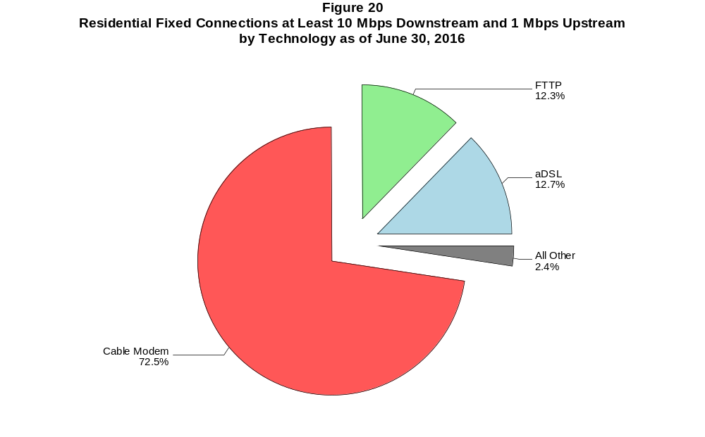

Figure 21
Fixed Connections at Least 25 Mbps Downstream and 3 Mbps Upstream by Technology 2014-2016
(In thousands)

 | 2014 |  | 2015 |  | 2016
Technology | Jun+ | Dec | Jun | Dec | Jun
Total Fixed | 35,927 | 42,390 | 48,449 | 54,360 | 58,774
aDSL | 420 | 598 | 761 | 938 | 1,239
sDSL | 2 | 2 | 1 | * | *
Other Wireline¹ | 114 | 125 | 125 | 141 | 158
Cable Modem | 30,769 | 36,095 | 40,646 | 45,530 | 48,694
FTTP² | 4,603 | 5,542 | 6,870 | 7,691 | 8,599
Satellite | # | # | # | * | *
Fixed Wireless | 19 | 28 | 47 | 55 | 68

¹ Power Line and Other are summarized with Other Wireline to maintain firm confidentiality. See Technical Notes at the end of the report for a description of
Form 477 technology categories and other reporting requirements.
² Fiber to the premises.
+ The June 2014 data have not been subjected to the typical quality checks (see Technical Notes).
* = Data withheld to maintain firm confidentiality.
# = Rounds to zero.

The Commission approved changes to the Form 477 in June 2013 that affect the data beginning in June 2014 (see Technical Notes).
Figures may not sum to totals due to rounding. Revised May 2, 2017.

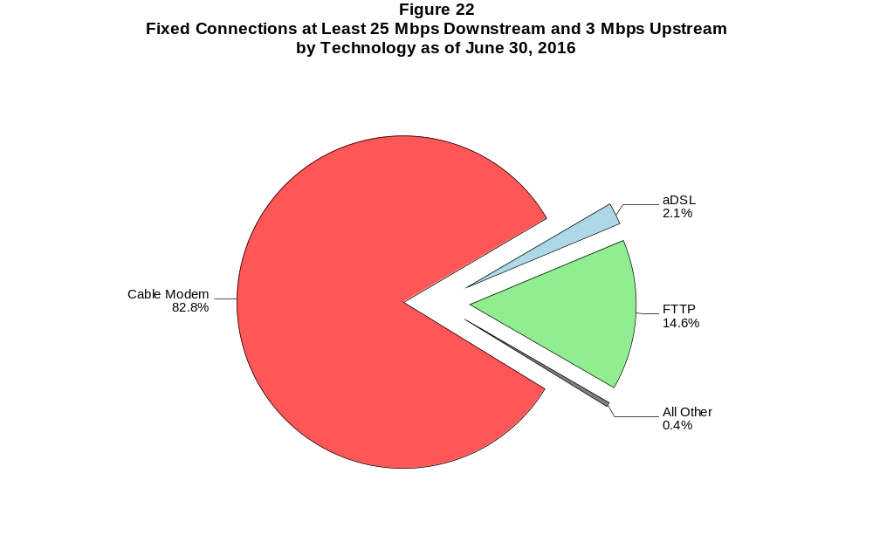

Figure 23
Residential Fixed Connections at Least 25 Mbps Downstream and 3 Mbps Upstream
by Technology 2014-2016
(In thousands)

 | 2014 |  | 2015 |  | 2016
Technology | Jun+ | Dec | Jun | Dec | Jun
Total Fixed | 34,439 | 40,595 | 46,198 | 51,811 | 55,718
aDSL | 397 | 566 | 727 | 897 | 1,173
sDSL | # | # | # | * | *
Other Wireline¹ | 22 | 26 | 26 | 31 | 41
Cable Modem | 29,806 | 34,914 | 39,083 | 43,746 | 46,526
FTTP² | 4,201 | 5,068 | 6,323 | 7,089 | 7,909
Satellite | 0 | 0 | 0 | * | *
Fixed Wireless | 14 | 22 | 40 | 46 | 54

¹ Power Line and Other are summarized with Other Wireline to maintain firm confidentiality. See Technical Notes at the end of the report for a description of
Form 477 technology categories and other reporting requirements.
² Fiber to the premises.
+ The June 2014 data have not been subjected to the typical quality checks (see Technical Notes).
* = Data withheld to maintain firm confidentiality.
# = Rounds to zero.

The Commission approved changes to the Form 477 in June 2013 that affect the data beginning in June 2014 (see Technical Notes).
Figures may not sum to totals due to rounding. Revised May 2, 2017.

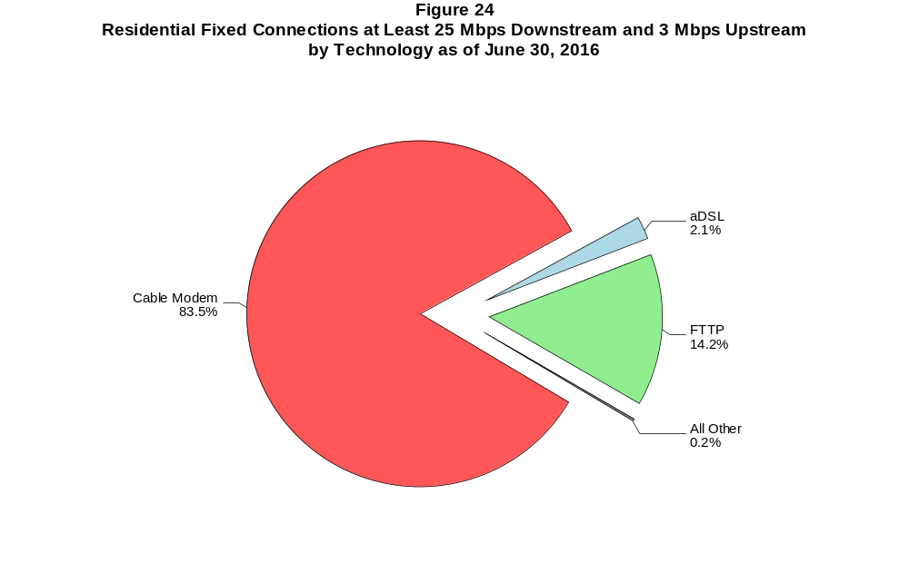

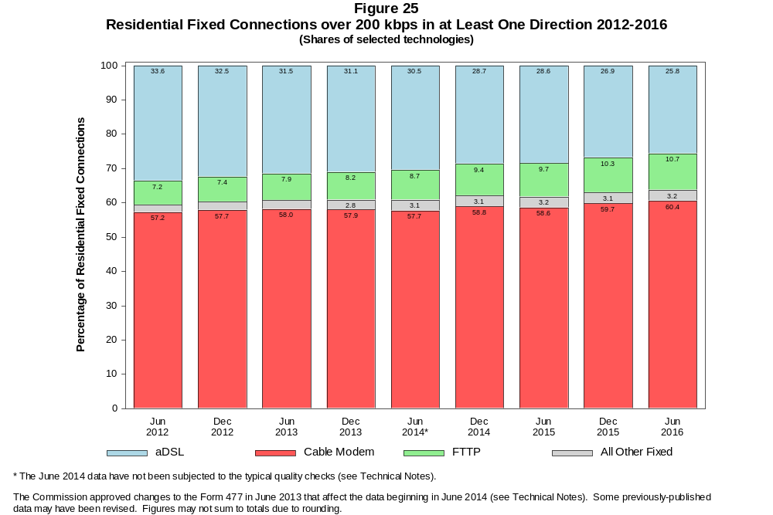

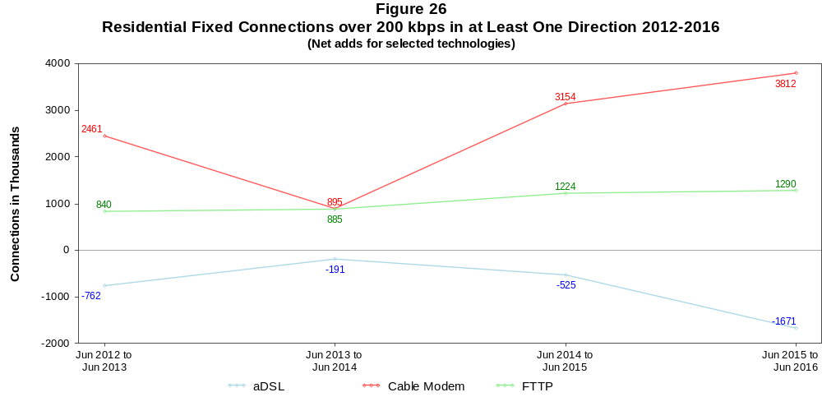

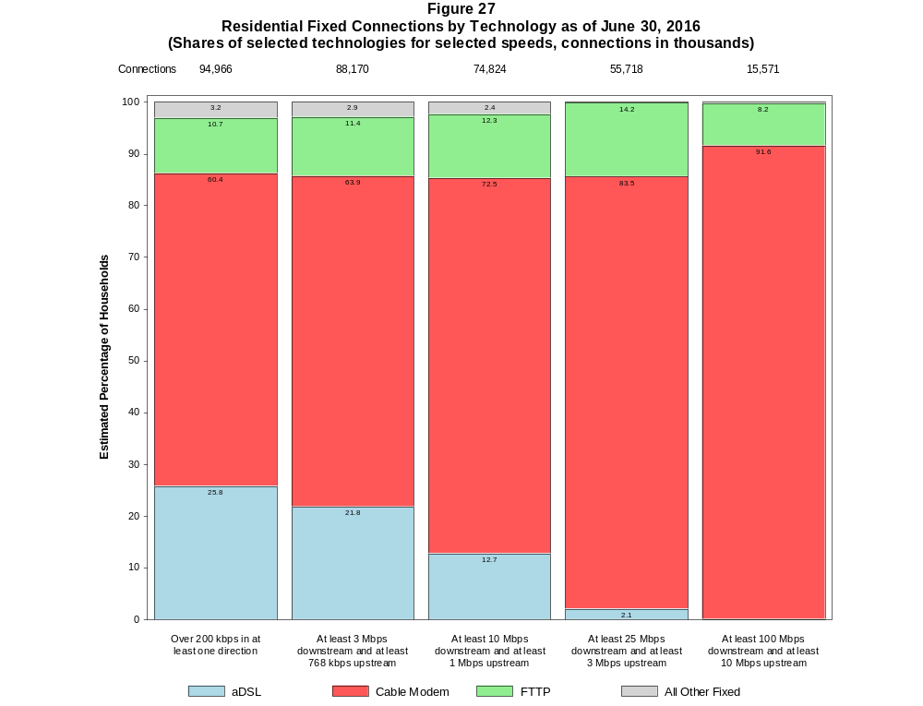

Figure 28
Fixed Connections by Downstream Speed Tier and Technology as of June 30, 2016
(In thousands)

 | Downstream Speed
Technology | Less than  1.5 Mbps | At least 1.5 Mbps  and less than  3 Mbps | At least 3 Mbps  and less than  10 Mbps | At least 10 Mbps  and less than  25 Mbps | At least 25 Mbps  and less than  100 Mbps | At least 100 Mbps | Total
aDSL | 1,147 | 2,114 | 11,446 | 11,359 | 1,408 | 10 | 27,484
sDSL | 21 | 15 | 12 | 6 | * | * | 56
Other Wireline¹ | 66 | 269 | 128 | 51 | 40 | 119 | 673
Cable Modem | 86 | 661 | 2,611 | 9,153 | 32,157 | 16,785 | 61,453
FTTP | 36 | 45 | 585 | 1,825 | 7,134 | 1,504 | 11,129
Satellite | 234 | 39 | 338 | 1,454 | * | * | 2,079
Fixed Wireless | 109 | 165 | 572 | 255 | 51 | 18 | 1,169
Total | 1,699 | 3,309 | 15,692 | 24,101 | 40,806 | 18,435 | 104,042

Percentages

aDSL | 1.1 | 2.0 | 11.0 | 10.9 | 1.4 | 0.0 | 26.4
sDSL | 0.0 | 0.0 | 0.0 | 0.0 | * | * | 0.1
Other Wireline¹ | 0.1 | 0.3 | 0.1 | 0.0 | 0.0 | 0.1 | 0.6
Cable Modem | 0.1 | 0.6 | 2.5 | 8.8 | 30.9 | 16.1 | 59.1
FTTP | 0.0 | 0.0 | 0.6 | 1.8 | 6.9 | 1.4 | 10.7
Satellite | 0.2 | 0.0 | 0.3 | 1.4 | * | * | 2.0
Fixed Wireless | 0.1 | 0.2 | 0.5 | 0.2 | 0.0 | 0.0 | 1.1
Total | 1.6 | 3.2 | 15.1 | 23.2 | 39.2 | 17.7 | 100.0

¹ Power Line and Other are summarized with Other Wireline to maintain firm confidentiality. See Technical Notes at the end of the report for a description of Form 477 technology categories
and other reporting requirements.
# = Rounds to Zero.
* = Data withheld to maintain firm confidentiality.
Note: Figures may not sum to totals due to rounding.
Source: FCC Form 477.

Figure 29
Residential Fixed Connections by Downstream Speed Tier and Technology as of June 30, 2016
(In thousands)

 | Downstream Speed
Technology | Less than  1.5 Mbps | At least 1.5 Mbps  and less than  3 Mbps | At least 3 Mbps  and less than  10 Mbps | At least 10 Mbps  and less than  25 Mbps | At least 25 Mbps  and less than  100 Mbps | At least 100 Mbps | Total
aDSL | 1,017 | 1,725 | 9,944 | 10,465 | 1,328 | 5 | 24,483
sDSL | 8 | 1 | 1 | 1 | * | * | 11
Other Wireline¹ | # | 1 | 2 | 6 | 13 | 28 | 51
Cable Modem | 81 | 618 | 2,266 | 7,636 | 30,399 | 16,354 | 57,354
FTTP | 19 | 30 | 515 | 1,624 | 6,670 | 1,273 | 10,131
Satellite | 88 | 16 | 333 | 1,446 | * | * | 1,897
Fixed Wireless | 99 | 151 | 511 | 223 | 42 | 13 | 1,039
Total | 1,312 | 2,542 | 13,571 | 21,401 | 38,466 | 17,674 | 94,966

Percentages

aDSL | 1.1 | 1.8 | 10.5 | 11.0 | 1.4 | 0.0 | 25.8
sDSL | 0.0 | 0.0 | 0.0 | 0.0 | * | * | 0.0
Other Wireline¹ | 0.0 | 0.0 | 0.0 | 0.0 | 0.0 | 0.0 | 0.1
Cable Modem | 0.1 | 0.7 | 2.4 | 8.0 | 32.0 | 17.2 | 60.4
FTTP | 0.0 | 0.0 | 0.5 | 1.7 | 7.0 | 1.3 | 10.7
Satellite | 0.1 | 0.0 | 0.4 | 1.5 | * | * | 2.0
Fixed Wireless | 0.1 | 0.2 | 0.5 | 0.2 | 0.0 | 0.0 | 1.1
Total | 1.4 | 2.7 | 14.3 | 22.5 | 40.5 | 18.6 | 100.0

¹ Power Line and Other are summarized with Other Wireline to maintain firm confidentiality. See Technical Notes at the end of the report for a description of Form 477 technology categories
and other reporting requirements.
# = Rounds to Zero.
* = Data withheld to maintain firm confidentiality.
Note: Figures may not sum to totals due to rounding.
Source: FCC Form 477.

Figure 30
Nationwide Number of Providers of Connections over 200 kbps in at Least One Direction
by Technology 2012-2016

 | 2012 |  | 2013 |  | 2014 |  | 2015 |  | 2016
Technology | Jun | Dec | Jun | Dec | Jun+ | Dec | Jun | Dec | Jun
aDSL | 860 | 865 | 852 | 851 | 794 | 792 | 790 | 775 | 762
sDSL | 251 | 255 | 246 | 239 | 195 | 191 | 177 | 181 | 170
Other Wireline¹ | 258 | 262 | 246 | 245 | 270 | 245 | 239 | 250 | 241
Cable Modem | 401 | 404 | 403 | 407 | 394 | 402 | 391 | 392 | 384
FTTP | 642 | 666 | 692 | 744 | 878 | 906 | 929 | 990 | 1,010
Satellite | 5 | 6 | 5 | 5 | 18 | 16 | 11 | 11 | 9
Fixed Wireless | 713 | 765 | 771 | 825 | 870 | 916 | 943 | 977 | 996
Mobile Wireless | 67 | 70 | 79 | 77 | 91 | 98 | 100 | 97 | 99
Power Line and Other¹ | * | * | 0 | * | - | - | - | - | -
Total | 1,673 | 1,722 | 1,714 | 1,773 | 1,813 | 1,865 | 1,874 | 1,911 | 1,919

¹ For this Figure, the categories Power Line and All Other were combined with Other Wireline from June 2014 forward.
+ The June 2014 data have not been subjected to the typical quality checks (see Technical Notes).
Multiple Form 477 filers within a holding company structure count as one provider. * = 1-3 providers.

The Commission approved changes to the Form 477 in June 2013 that affect the data beginning in June 2014 (see Technical Notes). Some previously-published
data may have been revised.

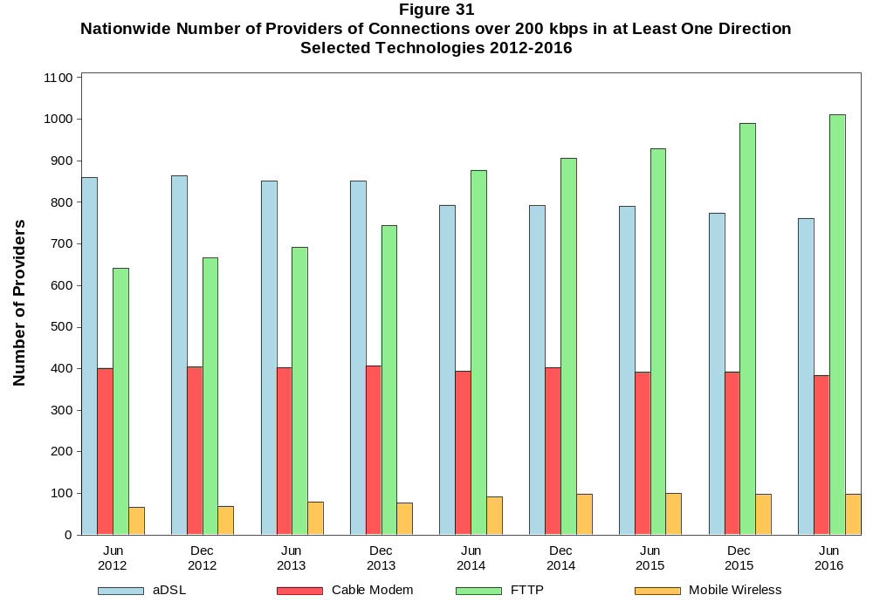

Figure 32
Residential Fixed Connections and Households by State as of June 30, 2016
(Connections and households, in thousands)

 |  | At least 200 kbps in  at least One Direction |  | At least 10 Mbps Down  and 1 Mbps Up |  | At least 25 Mbps Down  and 3 Mbps Up |  | At least 100 Mbps Down  and 10 Mbps Up
State | Households | Connections | Subscribership  Ratio | Connections | Subscribership  Ratio | Connections | Subscribership  Ratio | Connections | Subscribership  Ratio
Alabama | 1,848 | 1,261 | 0.68 | 905 | 0.49 | 579 | 0.31 | 50 | 0.03
Alaska | 251 | 204 | 0.81 | 141 | 0.56 | * | * | * | *
American Samoa | 10 | * | * | 0 | 0.00 | 0 | 0.00 | 0 | 0.00
Arizona | 2,412 | 1,975 | 0.82 | 1,390 | 0.58 | 1,121 | 0.46 | 329 | 0.14
Arkansas | 1,138 | 728 | 0.64 | 479 | 0.42 | 249 | 0.22 | 75 | 0.07
California | 12,718 | 10,832 | 0.85 | 8,987 | 0.71 | 6,650 | 0.52 | 2,433 | 0.19
Colorado | 2,024 | 1,795 | 0.89 | 1,254 | 0.62 | 1,156 | 0.57 | * | *
Connecticut | 1,353 | 1,174 | 0.87 | 1,008 | 0.75 | 811 | 0.60 | 222 | 0.16
Delaware | 344 | 318 | 0.92 | 292 | 0.85 | 269 | 0.78 | 85 | 0.25
District of Columbia | 273 | 231 | 0.84 | 204 | 0.74 | 193 | 0.71 | * | *
Florida | 7,300 | 6,525 | 0.89 | 5,473 | 0.75 | 4,093 | 0.56 | 976 | 0.13
Georgia | 3,574 | 2,821 | 0.79 | 2,144 | 0.60 | 1,506 | 0.42 | 243 | 0.07
Guam | 42 | * | * | * | * | * | * | 0 | 0.00
Hawaii | 451 | 398 | 0.88 | 390 | 0.86 | * | * | * | *
Idaho | 589 | 468 | 0.79 | 234 | 0.40 | 173 | 0.29 | 13 | 0.02
Illinois | 4,786 | 3,720 | 0.78 | 2,982 | 0.62 | 2,174 | 0.45 | 402 | 0.08
Indiana | 2,502 | 1,867 | 0.75 | 1,380 | 0.55 | 924 | 0.37 | 207 | 0.08
Iowa | 1,236 | 919 | 0.74 | 536 | 0.43 | 295 | 0.24 | 67 | 0.05
Kansas | 1,113 | 867 | 0.78 | 630 | 0.57 | 381 | 0.34 | 153 | 0.14
Kentucky | 1,708 | 1,261 | 0.74 | 835 | 0.49 | 438 | 0.26 | 232 | 0.14
Louisiana | 1,728 | 1,201 | 0.70 | 924 | 0.53 | 593 | 0.34 | 154 | 0.09
Maine | 553 | 489 | 0.88 | 345 | 0.62 | 138 | 0.25 | * | *
Maryland | 2,166 | 1,840 | 0.85 | 1,680 | 0.78 | 1,545 | 0.71 | 440 | 0.20
Massachusetts | 2,550 | 2,273 | 0.89 | 2,069 | 0.81 | 1,960 | 0.77 | 654 | 0.26
Michigan | 3,841 | 2,897 | 0.75 | 2,350 | 0.61 | 1,739 | 0.45 | 190 | 0.05
Minnesota | 2,125 | 1,694 | 0.80 | 1,153 | 0.54 | 987 | 0.46 | 250 | 0.12
Mississippi | 1,097 | 633 | 0.58 | 430 | 0.39 | 232 | 0.21 | 36 | 0.03
Missouri | 2,365 | 1,745 | 0.74 | 1,230 | 0.52 | 785 | 0.33 | 210 | 0.09
Montana | 409 | 319 | 0.78 | 186 | 0.45 | 169 | 0.41 | * | *
Nebraska | 737 | 567 | 0.77 | 379 | 0.52 | 255 | 0.35 | 41 | 0.06

Figure 32 - Continued
Residential Fixed Connections and Households by State as of June 30, 2016
(Connections and households, in thousands)

 |  | At least 200 kbps in  at least One Direction |  | At least 10 Mbps Down  and 1 Mbps Up |  | At least 25 Mbps Down  and 3 Mbps Up |  | At least 100 Mbps Down  and 10 Mbps Up
State | Households | Connections | Subscribership  Ratio | Connections | Subscribership  Ratio | Connections | Subscribership  Ratio | Connections | Subscribership  Ratio
Nevada | 1,017 | 851 | 0.84 | 667 | 0.66 | 504 | 0.50 | * | *
New Hampshire | 520 | 476 | 0.91 | 393 | 0.76 | 348 | 0.67 | 133 | 0.26
New Jersey | 3,189 | 2,889 | 0.91 | 2,681 | 0.84 | 2,594 | 0.81 | 660 | 0.21
New Mexico | 764 | 544 | 0.71 | 283 | 0.37 | 251 | 0.33 | 77 | 0.10
New York | 7,262 | 6,182 | 0.85 | 5,589 | 0.77 | 4,594 | 0.63 | 1,023 | 0.14
North Carolina | 3,776 | 3,067 | 0.81 | 2,272 | 0.60 | 1,708 | 0.45 | 870 | 0.23
North Dakota | 300 | 232 | 0.77 | 188 | 0.63 | 140 | 0.47 | 22 | 0.07
Northern Mariana Isl | 16 | * | * | 0 | 0.00 | 0 | 0.00 | 0 | 0.00
Ohio | 4,585 | 3,687 | 0.80 | 2,744 | 0.60 | 1,230 | 0.27 | 50 | 0.01
Oklahoma | 1,455 | 995 | 0.68 | 694 | 0.48 | 408 | 0.28 | 102 | 0.07
Oregon | 1,533 | 1,278 | 0.83 | 965 | 0.63 | 861 | 0.56 | * | *
Pennsylvania | 4,959 | 3,952 | 0.80 | 3,098 | 0.62 | 2,740 | 0.55 | 857 | 0.17
Puerto Rico | 1,244 | * | * | * | * | * | * | * | *
Rhode Island | 411 | 348 | 0.85 | 333 | 0.81 | * | * | * | *
South Carolina | 1,815 | 1,397 | 0.77 | 1,093 | 0.60 | 548 | 0.30 | 28 | 0.02
South Dakota | 331 | 249 | 0.75 | 208 | 0.63 | 154 | 0.47 | 17 | 0.05
Tennessee | 2,505 | 1,781 | 0.71 | 1,428 | 0.57 | 1,065 | 0.43 | 195 | 0.08
Texas | 9,149 | 7,015 | 0.77 | 5,522 | 0.60 | 3,394 | 0.37 | 1,500 | 0.16
Utah | 906 | 784 | 0.87 | 527 | 0.58 | 457 | 0.50 | 181 | 0.20
Vermont | 257 | 234 | 0.91 | 157 | 0.61 | 126 | 0.49 | 49 | 0.19
Virgin Islands | 43 | * | * | * | * | * | * | 0 | 0.00
Virginia | 3,063 | 2,480 | 0.81 | 2,106 | 0.69 | 1,821 | 0.59 | 463 | 0.15
Washington | 2,669 | 2,329 | 0.87 | 1,806 | 0.68 | 1,645 | 0.62 | 657 | 0.25
West Virginia | 741 | 506 | 0.68 | 337 | 0.46 | 272 | 0.37 | * | *
Wisconsin | 2,299 | 1,809 | 0.79 | 1,344 | 0.58 | 738 | 0.32 | 16 | 0.01
Wyoming | 227 | 177 | 0.78 | 116 | 0.51 | 97 | 0.43 | # | 0.00
Total | 118,281 | 94,966 | 0.80 | 74,824 | 0.63 | 55,718 | 0.47 | 15,571 | 0.13

# = Rounds to Zero; * = Data withheld to maintain firm confidentiality.
Note: Figures may not sum to totals due to rounding.
Sources: FCC Form 477 (Connections); 2011-2015 ACS 5-year estimates; Census 2010.

Figure 33
Connections by Type of End User by State as of June 30, 2016
(Connections over 200 kbps in at least one direction, in thousands)

 | Connections |  | Percentages
State | Residential | Business | Residential | Business | Total
Alabama | 4,515 | 586 | 88.5 | 11.5 | 5,101
Alaska | 792 | 136 | 85.4 | 14.6 | 928
American Samoa | * | * | * | * | *
Arizona | 6,205 | 960 | 86.6 | 13.4 | 7,165
Arkansas | 2,711 | 389 | 87.5 | 12.5 | 3,100
California | 38,975 | 7,237 | 84.3 | 15.7 | 46,212
Colorado | 5,519 | 888 | 86.1 | 13.9 | 6,408
Connecticut | 3,798 | 675 | 84.9 | 15.1 | 4,473
Delaware | 980 | 152 | 86.6 | 13.4 | 1,132
District of Columbia | 869 | 479 | 64.5 | 35.5 | 1,348
Florida | 18,858 | 3,377 | 84.8 | 15.2 | 22,234
Georgia | 9,531 | 1,550 | 86.0 | 14.0 | 11,080
Guam | 102 | 41 | 71.2 | 28.8 | 144
Hawaii | 1,546 | 202 | 88.4 | 11.6 | 1,748
Idaho | 1,529 | 233 | 86.8 | 13.2 | 1,762
Illinois | 12,880 | 2,183 | 85.5 | 14.5 | 15,063
Indiana | 6,201 | 866 | 87.8 | 12.2 | 7,066
Iowa | 2,932 | 495 | 85.6 | 14.4 | 3,427
Kansas | 3,500 | 460 | 88.4 | 11.6 | 3,960
Kentucky | 5,201 | 576 | 90.0 | 10.0 | 5,777
Louisiana | 4,645 | 640 | 87.9 | 12.1 | 5,285
Maine | 1,280 | 201 | 86.4 | 13.6 | 1,480
Maryland | 6,053 | 1,023 | 85.5 | 14.5 | 7,076
Massachusetts | 7,019 | 1,227 | 85.1 | 14.9 | 8,246
Michigan | 8,986 | 1,677 | 84.3 | 15.7 | 10,663
Minnesota | 5,399 | 939 | 85.2 | 14.8 | 6,338
Mississippi | 2,800 | 300 | 90.3 | 9.7 | 3,100
Missouri | 5,794 | 972 | 85.6 | 14.4 | 6,765
Montana | 968 | 130 | 88.1 | 11.9 | 1,099
Nebraska | 1,689 | 336 | 83.4 | 16.6 | 2,026
Nevada | 2,822 | 387 | 87.9 | 12.1 | 3,209
New Hampshire | 1,360 | 208 | 86.7 | 13.3 | 1,568
New Jersey | 9,707 | 1,786 | 84.5 | 15.5 | 11,493
New Mexico | 1,815 | 249 | 87.9 | 12.1 | 2,064
New York | 20,074 | 3,496 | 85.2 | 14.8 | 23,570
North Carolina | 9,742 | 1,538 | 86.4 | 13.6 | 11,280
North Dakota | 741 | 125 | 85.6 | 14.4 | 866
Northern Mariana Isl | * | * | * | * | *
Ohio | 11,407 | 1,772 | 86.6 | 13.4 | 13,179
Oklahoma | 3,650 | 565 | 86.6 | 13.4 | 4,215
Oregon | 4,003 | 654 | 86.0 | 14.0 | 4,657
Pennsylvania | 12,460 | 1,959 | 86.4 | 13.6 | 14,419
Puerto Rico | 3,260 | 265 | 92.5 | 7.5 | 3,525
Rhode Island | 1,033 | 173 | 85.6 | 14.4 | 1,207
South Carolina | 4,462 | 623 | 87.7 | 12.3 | 5,086
South Dakota | 793 | 106 | 88.2 | 11.8 | 899
Tennessee | 6,116 | 982 | 86.2 | 13.8 | 7,099
Texas | 25,512 | 4,659 | 84.6 | 15.4 | 30,171
Utah | 2,698 | 468 | 85.2 | 14.8 | 3,166
Vermont | 626 | 124 | 83.4 | 16.6 | 751
Virgin Islands | 99 | 16 | 86.2 | 13.8 | 115
Virginia | 7,747 | 1,448 | 84.2 | 15.8 | 9,195
Washington | 7,446 | 1,224 | 85.9 | 14.1 | 8,670
West Virginia | 1,529 | 176 | 89.7 | 10.3 | 1,705
Wisconsin | 5,420 | 927 | 85.4 | 14.6 | 6,347
Wyoming | 590 | 80 | 88.0 | 12.0 | 671
Total | 316,454 | 52,962 | 85.7 | 14.3 | 369,416

# = Rounds to Zero.
* = Data withheld to maintain firm confidentiality.
Figures may not sum to totals due to rounding.
Source: FCC Form 477.

Figure 34
Connections by Technology by State as of June 30, 2016
(Connections over 200 kbps in at least one direction, in thousands)

State | ADSL | SDSL | Other  Wireline¹ | Cable  Modem | Fiber | Satellite | Fixed  Wireless | Mobile  Wireless | Total
Alabama | 526 | 3 | * | 738 | 38 | * | 5 | 3,715 | 5,101
Alaska | 78 | # | 3 | * | 4 | * | 7 | 687 | 928
American Samoa | 0 | 0 | 0 | * | * | 0 | * | * | *
Arizona | 602 | # | * | 1,326 | 127 | * | 30 | 5,036 | 7,165
Arkansas | 345 | # | * | 364 | 18 | * | 7 | 2,307 | 3,100
California | 3,611 | 9 | * | 7,033 | 920 | * | 75 | 34,320 | 46,212
Colorado | 553 | 1 | * | 1,119 | 177 | * | 60 | 4,442 | 6,408
Connecticut | * | # | 4 | 919 | 8 | * | * | 3,182 | 4,473
Delaware | * | # | 4 | 207 | * | * | * | 786 | 1,132
District of Columbia | 39 | 1 | 7 | * | * | * | * | 1,080 | 1,348
Florida | 1,763 | 1 | * | 4,599 | 633 | * | 11 | 15,085 | 22,234
Georgia | 1,108 | 1 | * | 1,755 | 140 | * | 2 | 7,972 | 11,080
Guam | * | 0 | * | * | * | 0 | 0 | 104 | 144
Hawaii | * | 2 | 1 | * | 29 | * | 4 | 1,317 | 1,748
Idaho | 195 | # | * | 192 | 61 | * | 49 | 1,250 | 1,762
Illinois | 1,303 | 2 | * | 2,534 | 73 | * | 76 | 10,997 | 15,063
Indiana | 714 | 1 | * | 1,051 | 157 | * | 42 | 5,035 | 7,066
Iowa | 334 | 1 | * | 459 | 145 | * | 34 | 2,420 | 3,427
Kansas | 261 | # | * | 492 | 130 | * | 38 | 3,012 | 3,960
Kentucky | 480 | # | * | 746 | 77 | * | 15 | 4,402 | 5,777
Louisiana | 427 | # | * | 752 | 64 | * | 5 | 3,967 | 5,285
Maine | 133 | 2 | * | 379 | 8 | * | 4 | 942 | 1,480
Maryland | 171 | 1 | 16 | 1,026 | * | * | 4 | 5,071 | 7,076
Massachusetts | * | 1 | 19 | 1,780 | * | * | 2 | 5,751 | 8,246
Michigan | 897 | 4 | * | 2,070 | 21 | * | 46 | 7,507 | 10,663
Minnesota | 562 | 3 | * | 1,033 | 173 | * | 28 | 4,494 | 6,338
Mississippi | 328 | # | * | 301 | 17 | * | 2 | 2,388 | 3,100
Missouri | 765 | # | * | 856 | 151 | * | 36 | 4,867 | 6,765
Montana | 112 | 1 | * | 187 | 22 | * | 23 | 740 | 1,099
Nebraska | 171 | # | * | 372 | 46 | * | 23 | 1,402 | 2,026

Figure 34 - Continued
Connections by Technology by State as of June 30, 2016
(Connections over 200 kbps in at least one direction, in thousands)

State | ADSL | SDSL | Other  Wireline¹ | Cable  Modem | Fiber | Satellite | Fixed  Wireless | Mobile  Wireless | Total
Nevada | 243 | # | 6 | * | 11 | * | 12 | 2,277 | 3,209
New Hampshire | 84 | # | 4 | 412 | 24 | * | * | 1,037 | 1,568
New Jersey | 222 | 1 | 26 | 2,009 | * | * | # | 8,301 | 11,493
New Mexico | 270 | # | * | 258 | 33 | * | 19 | 1,467 | 2,064
New York | 543 | 3 | 36 | 4,681 | * | * | 4 | 16,757 | 23,570
North Carolina | 982 | # | * | 2,144 | 137 | * | 4 | 7,936 | 11,280
North Dakota | 55 | # | * | 129 | 69 | * | 5 | 604 | 866
Northern Mariana Isl | * | 0 | * | * | * | 0 | 0 | * | *
Ohio | 1,175 | 1 | * | 2,562 | 153 | * | 41 | 9,180 | 13,179
Oklahoma | 388 | # | * | 560 | 33 | * | 46 | 3,124 | 4,215
Oregon | 305 | 1 | * | 865 | 165 | * | 21 | 3,259 | 4,657
Pennsylvania | 740 | 1 | 25 | 2,637 | * | * | 6 | 10,085 | 14,419
Puerto Rico | * | * | * | * | 5 | * | 2 | 2,839 | 3,525
Rhode Island | * | # | 2 | * | * | * | * | 827 | 1,207
South Carolina | 477 | # | * | 915 | 77 | * | 3 | 3,566 | 5,086
South Dakota | 53 | * | # | 158 | 50 | * | 10 | 623 | 899
Tennessee | 579 | # | * | 1,124 | 186 | * | 8 | 5,123 | 7,099
Texas | 2,718 | 1 | * | 3,650 | 813 | * | 191 | 22,522 | 30,171
Utah | 210 | # | * | 435 | 141 | * | 58 | 2,312 | 3,166
Vermont | 122 | * | 3 | 134 | 20 | * | 1 | 464 | 751
Virgin Islands | * | 0 | * | * | * | * | * | 90 | 115
Virginia | 355 | 1 | * | 1,399 | 833 | * | 15 | 6,478 | 9,195
Washington | 518 | 1 | * | 1,702 | 208 | * | 25 | 6,142 | 8,670
West Virginia | * | * | 1 | 317 | 9 | * | 2 | 1,156 | 1,705
Wisconsin | 657 | 6 | 5 | * | 69 | * | 38 | 4,379 | 6,347
Wyoming | 56 | 1 | * | 104 | 9 | * | 21 | 470 | 671
Total | 27,484 | 56 | 673 | 61,453 | 11,129 | 2,079 | 1,169 | 265,374 | 369,416

¹ PowerLine and Other are summarized with Other Wireline to maintain firm confidentiality. See Technical Notes at the end of the report for a description of Form 477 technology categories and
other reporting requirements.
# = Rounds to Zero.
* = Data withheld to maintain firm confidentiality.
Figures may not sum to totals due to rounding.
Source: FCC Form 477.

Figure 35
Percentage of Fixed Connections by Downstream Speed by State as of June 30, 2016

 | Over 200 kbps Upstream and
State | % over 200 kbps  Downstream | % at least 3 Mbps  Downstream | % at least 10 Mbps  Downstream | % at least 25 Mbps  Downstream | % at least 100 Mbps  Downstream
Alabama | 99.2 | 92.6 | 73.8 | 45.9 | 5.6
Alaska | 97.2 | 84.7 | 67.5 | 35.5 | 14.0
American Samoa | * | * | * | * | *
Arizona | 99.6 | 95.7 | 82.2 | 55.1 | 20.3
Arkansas | 99.2 | 91.7 | 69.0 | 37.0 | 15.2
California | 99.6 | 96.5 | 80.7 | 58.5 | 28.4
Colorado | 99.7 | 94.1 | 83.2 | 61.8 | 25.2
Connecticut | 99.3 | 98.7 | 84.4 | 66.9 | 18.0
Delaware | 99.8 | 97.9 | 90.7 | 81.7 | 25.5
District of Columbia | 99.8 | 96.5 | 84.9 | 78.5 | 28.3
Florida | 99.5 | 96.2 | 86.1 | 61.3 | 14.6
Georgia | 99.0 | 94.6 | 76.5 | 52.2 | 8.6
Guam | * | * | * | * | *
Hawaii | 100.0 | 98.7 | 96.5 | 39.8 | 13.3
Idaho | 99.4 | 92.1 | 66.2 | 36.3 | 24.8
Illinois | 99.6 | 96.8 | 79.4 | 56.2 | 13.4
Indiana | 99.2 | 95.3 | 74.8 | 47.6 | 10.6
Iowa | 99.5 | 91.4 | 67.3 | 31.8 | 8.7
Kansas | 99.6 | 94.6 | 73.2 | 42.0 | 17.7
Kentucky | 98.9 | 90.5 | 66.8 | 33.9 | 17.2
Louisiana | 99.1 | 93.5 | 76.4 | 48.4 | 14.3
Maine | 98.7 | 90.8 | 69.0 | 26.9 | 1.8
Maryland | 99.7 | 97.5 | 89.4 | 81.3 | 23.0
Massachusetts | 99.8 | 97.6 | 89.7 | 83.2 | 27.4
Michigan | 99.3 | 96.5 | 80.4 | 58.0 | 6.6
Minnesota | 99.6 | 94.1 | 78.2 | 57.0 | 14.4
Mississippi | 98.7 | 91.0 | 68.3 | 37.3 | 14.6
Missouri | 99.3 | 93.1 | 74.6 | 44.9 | 33.3
Montana | 99.4 | 87.8 | 63.8 | 52.1 | 1.8
Nebraska | 99.6 | 94.1 | 71.3 | 44.0 | 8.3

Figure 35 - Continued
Percentage of Fixed Connections by Downstream Speed by State as of June 30, 2016

 | Over 200 kbps Upstream and
State | % over 200 kbps  Downstream | % at least 3 Mbps  Downstream | % at least 10 Mbps  Downstream | % at least 25 Mbps  Downstream | % at least 100 Mbps  Downstream
Nevada | 99.8 | 97.3 | 84.8 | 59.0 | 13.0
New Hampshire | 98.9 | 95.0 | 81.0 | 68.7 | 25.6
New Jersey | 99.7 | 97.9 | 92.0 | 87.4 | 21.8
New Mexico | 99.6 | 90.6 | 68.8 | 44.2 | 15.5
New York | 99.6 | 96.9 | 88.5 | 72.1 | 15.9
North Carolina | 99.4 | 93.0 | 77.9 | 53.2 | 26.9
North Dakota | 99.8 | 95.4 | 81.9 | 61.0 | 15.6
Northern Mariana Isl | * | * | * | * | *
Ohio | 99.7 | 93.3 | 74.7 | 32.3 | 1.8
Oklahoma | 99.5 | 95.4 | 69.5 | 40.5 | 14.8
Oregon | 99.7 | 94.8 | 82.1 | 65.4 | 20.2
Pennsylvania | 99.6 | 95.4 | 79.7 | 67.9 | 21.1
Puerto Rico | 99.9 | 76.8 | 45.1 | 13.1 | 0.5
Rhode Island | 99.6 | 98.4 | 93.7 | 81.7 | 14.4
South Carolina | 99.3 | 93.7 | 78.4 | 39.2 | 2.6
South Dakota | 99.6 | 95.8 | 84.9 | 61.4 | 7.8
Tennessee | 99.2 | 95.2 | 80.2 | 57.9 | 11.1
Texas | 99.7 | 95.6 | 78.0 | 46.9 | 21.8
Utah | 99.8 | 95.6 | 79.0 | 56.3 | 22.1
Vermont | 98.4 | 84.3 | 62.9 | 46.9 | 17.8
Virgin Islands | 99.9 | 83.1 | 25.0 | * | *
Virginia | 99.5 | 96.2 | 84.4 | 70.5 | 18.0
Washington | 99.4 | 95.3 | 83.6 | 68.3 | 27.3
West Virginia | 98.7 | 96.8 | 64.3 | 51.7 | 34.2
Wisconsin | 99.4 | 92.4 | 76.8 | 40.3 | 1.4
Wyoming | 99.5 | 89.9 | 72.1 | 53.3 | 0.8
Total | 99.5 | 95.2 | 80.1 | 56.9 | 17.7

Figure 36
Providers of Connections by Technology by State as of June 30, 2016
(Connections over 200 kbps in at least one direction, in thousands)

State | ADSL | SDSL | Other  Wireline¹ | Cable  Modem | Fiber | Satellite | Fixed  Wireless | Mobile  Wireless | Total
Alabama | 26 | 11 | * | 23 | 36 | * | 20 | 6 | 87
Alaska | 14 | 4 | 14 | * | 7 | * | 12 | 7 | 38
American Samoa | 0 | 0 | 0 | * | * | 0 | * | * | *
Arizona | 27 | 6 | * | 17 | 35 | * | 38 | 7 | 101
Arkansas | 24 | 6 | * | 20 | 30 | * | 19 | 4 | 76
California | 37 | 13 | * | 27 | 57 | * | 86 | 6 | 171
Colorado | 35 | 7 | * | 18 | 50 | * | 56 | 10 | 128
Connecticut | * | 8 | 19 | 10 | 21 | * | * | 4 | 44
Delaware | * | 4 | 17 | 6 | * | * | * | 4 | 32
District of Columbia | 10 | 6 | 20 | * | * | * | * | 4 | 45
Florida | 30 | 12 | * | 26 | 52 | * | 27 | 5 | 104
Georgia | 32 | 9 | * | 36 | 69 | * | 16 | 4 | 118
Guam | * | 0 | * | * | * | 0 | 0 | 4 | 4
Hawaii | * | 5 | 10 | * | 9 | * | 5 | 5 | 25
Idaho | 27 | 5 | * | 17 | 30 | * | 34 | 9 | 81
Illinois | 54 | 11 | * | 22 | 84 | * | 71 | 8 | 177
Indiana | 40 | 9 | * | 15 | 53 | * | 51 | 5 | 112
Iowa | 111 | 25 | * | 45 | 126 | * | 80 | 36 | 227
Kansas | 32 | 13 | * | 29 | 58 | * | 47 | 9 | 116
Kentucky | 24 | 8 | * | 30 | 43 | * | 29 | 6 | 100
Louisiana | 16 | 5 | * | 23 | 28 | * | 12 | 5 | 68
Maine | 17 | 8 | * | 9 | 18 | * | 10 | 5 | 43
Maryland | 19 | 10 | 27 | 17 | * | * | 18 | 5 | 75
Massachusetts | * | 7 | 30 | 11 | * | * | 16 | 4 | 67
Michigan | 35 | 12 | * | 24 | 50 | * | 39 | 6 | 115
Minnesota | 51 | 13 | * | 24 | 73 | * | 46 | 5 | 129
Mississippi | 18 | 4 | * | 19 | 20 | * | 12 | 5 | 64
Missouri | 39 | 13 | * | 21 | 54 | * | 60 | 8 | 141
Montana | 26 | 8 | * | 10 | 27 | * | 25 | 5 | 62
Nebraska | 34 | 5 | * | 23 | 44 | * | 37 | 8 | 89

Figure 36 - Continued
Providers of Connections by Technology by State as of June 30, 2016
(Connections over 200 kbps in at least one direction, in thousands)

State | ADSL | SDSL | Other  Wireline¹ | Cable  Modem | Fiber | Satellite | Fixed  Wireless | Mobile  Wireless | Total
Nevada | 20 | 8 | 29 | * | 27 | * | 17 | 6 | 64
New Hampshire | 15 | 8 | 20 | 6 | 22 | * | * | 6 | 43
New Jersey | 21 | 8 | 35 | 13 | * | * | 5 | 4 | 64
New Mexico | 26 | 7 | * | 12 | 24 | * | 24 | 9 | 68
New York | 43 | 8 | 35 | 22 | * | * | 25 | 5 | 106
North Carolina | 26 | 9 | * | 27 | 46 | * | 14 | 6 | 90
North Dakota | 28 | 7 | * | 8 | 28 | * | 16 | 7 | 54
Northern Mariana Isl | * | 0 | * | * | * | 0 | 0 | * | *
Ohio | 41 | 9 | * | 31 | 67 | * | 45 | 4 | 134
Oklahoma | 37 | 10 | * | 15 | 37 | * | 41 | 11 | 99
Oregon | 44 | 12 | * | 18 | 48 | * | 40 | 6 | 102
Pennsylvania | 34 | 9 | 39 | 30 | * | * | 24 | 7 | 118
Puerto Rico | * | * | * | * | 6 | * | 5 | 5 | 17
Rhode Island | * | 6 | 11 | * | * | * | * | 4 | 27
South Carolina | 21 | 4 | * | 18 | 25 | * | 8 | 6 | 54
South Dakota | 26 | * | 13 | 8 | 30 | * | 24 | 9 | 73
Tennessee | 26 | 9 | * | 24 | 42 | * | 26 | 7 | 99
Texas | 67 | 19 | * | 41 | 95 | * | 115 | 10 | 227
Utah | 23 | 7 | * | 14 | 26 | * | 27 | 9 | 76
Vermont | 13 | * | 11 | 7 | 18 | * | 4 | 6 | 36
Virgin Islands | * | 0 | * | * | * | * | * | 4 | 7
Virginia | 31 | 11 | * | 20 | 52 | * | 30 | 6 | 105
Washington | 31 | 9 | * | 25 | 50 | * | 52 | 6 | 118
West Virginia | * | * | 17 | 16 | 17 | * | 10 | 6 | 54
Wisconsin | 49 | 9 | 27 | * | 60 | * | 47 | 7 | 130
Wyoming | 19 | 6 | * | 8 | 17 | * | 21 | 8 | 53
Total | 762 | 170 | 241 | 384 | 1,010 | 9 | 996 | 99 | 1,919

¹ Power Line and Other are summarized with Other Wireline. See Technical Notes at the end of the report for a description of Form 477 technology categories and other reporting requirements.
# = Rounds to Zero.
* = Data withheld to maintain firm confidentiality.
Figures may not sum to totals due to rounding.
Source: FCC Form 477.

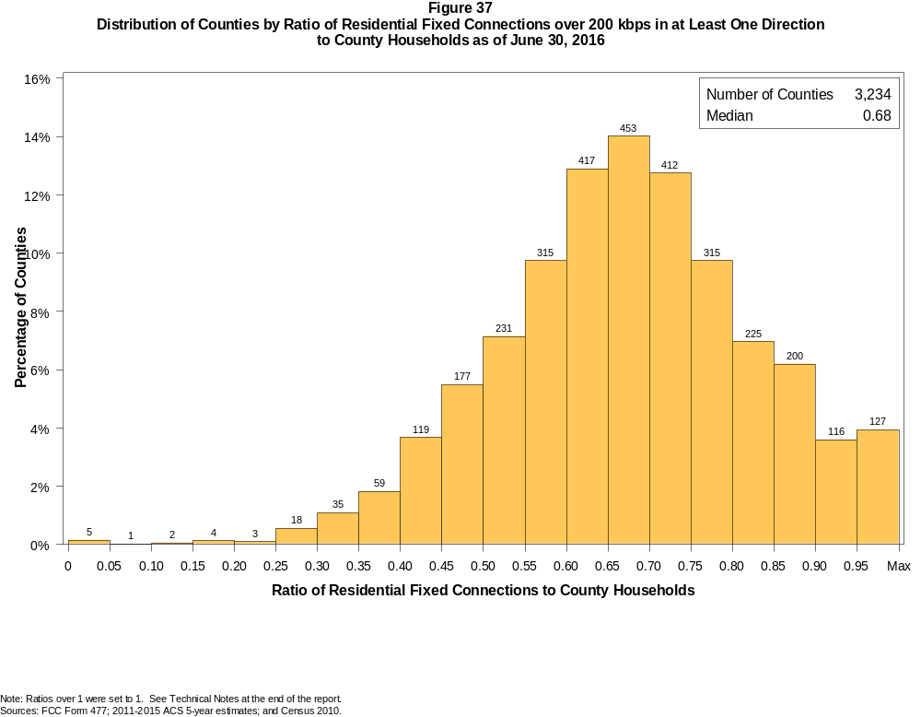

Figure 38
Distribution of Counties by Ratio of Residential Fixed Connections over 200 kbps in at Least One Direction
to County Households by Technology as of June 30, 2016

 | Ratio of Residential Fixed Connections to County Households
Technology | Zero | Greater than 0 and no more than 5% | Greater than 5 and no more than 10% | Greater than 10 and no more than 20% | Greater than 20 and no more than 30% | Greater than 30 and no more than 40% | Greater than 40 and no more than 50% | Greater than 50 and no more than 60% | Greater than 60 and no more than 80% | Greater than 80 and no more than 100% | 100% or more
aDSL | 0.8 | 5.0 | 5.7 | 24.9 | 30.5 | 19.3 | 8.5 | 3.4 | 1.5 | 0.3 | 0.2
sDSL | 88.5 | 11.3 | 0.1 | 0.0 | 0.1 | 0.0 | 0.0 | 0.0 | 0.0 | 0.0 | 0.0
Other Wireline | 91.9 | 7.9 | 0.1 | 0.1 | 0.0 | 0.0 | 0.0 | 0.0 | 0.0 | 0.0 | 0.0
Cable Modem | 12.1 | 7.1 | 6.8 | 16.0 | 14.6 | 14.0 | 11.5 | 10.4 | 6.5 | 0.7 | 0.3
FTTP | 29.0 | 45.4 | 7.4 | 7.4 | 3.9 | 2.7 | 1.6 | 1.3 | 1.4 | 0.0 | 0.0
Satellite | 1.0 | 62.4 | 24.7 | 10.4 | 1.3 | 0.2 | 0.0 | 0.0 | 0.0 | 0.0 | 0.0
Fixed Wireless | 30.4 | 49.8 | 10.6 | 6.6 | 1.7 | 0.5 | 0.2 | 0.1 | 0.0 | 0.0 | 0.0
Total | 0.2 | 0.0 | 0.0 | 0.2 | 0.6 | 2.9 | 9.2 | 16.9 | 49.4 | 18.2 | 2.4

¹ Power Line and Other are summarized with Other Wireline. See Technical Notes at the end of the report for a description of Form 477 technology categories and other reporting requirements.
Note: Figures may not sum to totals due to rounding.
Sources: FCC Form 477; 2011-2015 ACS 5-year estimates; and Census 2010.

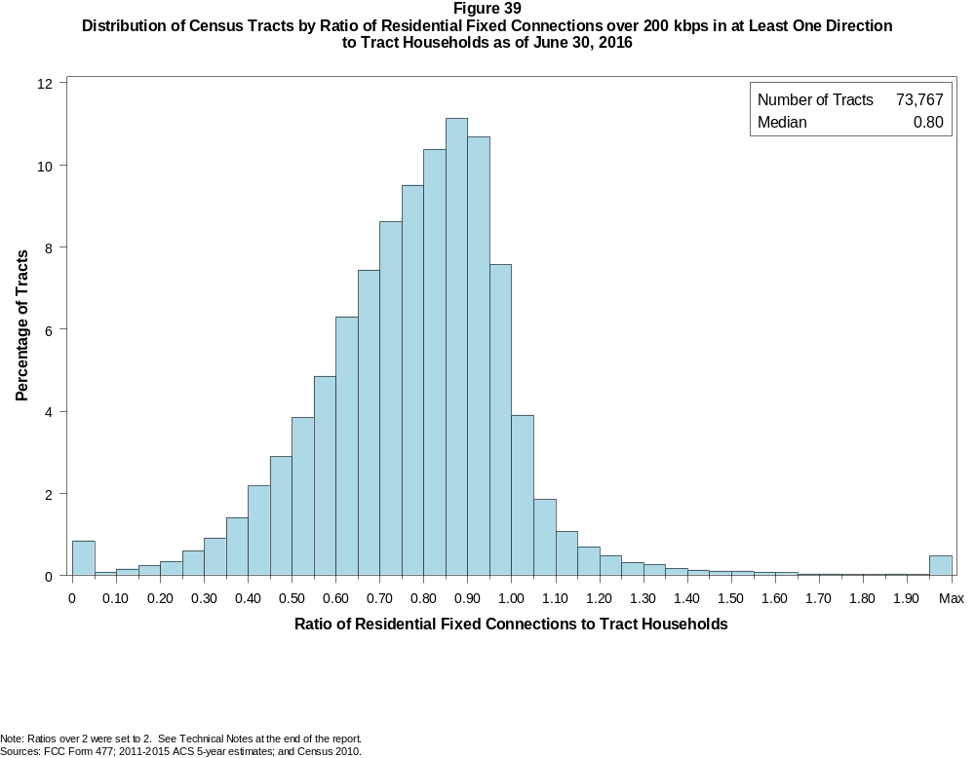

Figure 40
Distribution of Census Tracts by Ratio of Residential Fixed Connections over 200 kbps in at Least One Direction
to Tract Households by Technology as of June 30, 2016

 | Ratio of Residential Fixed Connections to Tract Households
Technology | Zero | Greater than 0 and no more than 5% | Greater than 5 and no more than 10% | Greater than 10 and no more than 20% | Greater than 20 and no more than 30% | Greater than 30 and no more than 40% | Greater than 40 and no more than 50% | Greater than 50 and no more than 60% | Greater than 60 and no more than 80% | Greater than 80 and no more than 100% | 100% or more
aDSL | 1.6 | 16.6 | 11.5 | 24.7 | 21.1 | 13.8 | 6.3 | 2.5 | 1.2 | 0.3 | 0.2
sDSL | 98.3 | 1.6 | 0.0 | 0.0 | 0.0 | 0.0 | 0.0 | 0.0 | 0.0 | 0.0 | 0.0
Other Wireline | 99.0 | 0.8 | 0.1 | 0.1 | 0.0 | 0.0 | 0.0 | 0.0 | 0.0 | 0.0 | 0.0
Cable Modem | 5.0 | 3.0 | 1.9 | 4.6 | 8.3 | 14.0 | 17.8 | 17.9 | 20.9 | 5.1 | 1.5
FTTP | 56.9 | 16.7 | 3.9 | 5.9 | 4.1 | 4.1 | 3.6 | 2.5 | 1.9 | 0.2 | 0.1
Satellite | 26.1 | 63.4 | 5.6 | 3.6 | 0.9 | 0.3 | 0.1 | 0.0 | 0.0 | 0.0 | 0.0
Fixed Wireless | 76.1 | 18.4 | 2.5 | 1.9 | 0.6 | 0.3 | 0.1 | 0.0 | 0.0 | 0.0 | 0.0
Total | 0.7 | 0.1 | 0.1 | 0.4 | 0.9 | 2.3 | 5.1 | 8.7 | 31.9 | 39.8 | 9.9

¹ Power Line and Other are summarized with Other Wireline. See Technical Notes at the end of the report for a description of Form 477 technology categories and other reporting requirements.
Note: Figures may not sum to totals due to rounding.
Sources: FCC Form 477; 2011-2015 ACS 5-year estimates; and Census 2010.

Figure 41
Percentage of Developed Census Blocks with Residential Fixed Service by Technology as of June 30, 2016
(Internet Access Service over 200 kbps in at least one direction)

 | Number of Providers
Technology | Zero | One | Two | Three | Four | Five | Six | Seven or More
aDSL | 25.9 | 69.6 | 4.3 | 0.2 | 0.0 | 0.0 | 0.0 | 0.0
sDSL | 99.3 | 0.7 | 0.0 | 0.0 | 0.0 | 0.0 | 0.0 | 0.0
Other Wireline¹ | 98.4 | 1.6 | 0.0 | 0.0 | 0.0 | 0.0 | 0.0 | 0.0
Cable Modem | 34.1 | 62.0 | 3.6 | 0.3 | 0.0 | 0.0 | 0.0 | 0.0
FTTP | 83.3 | 16.3 | 0.4 | 0.0 | 0.0 | 0.0 | 0.0 | 0.0
Satellite | 0.1 | 0.9 | 0.2 | 98.8 | 0.0 | 0.0 | 0.0 | 0.0
Fixed Wireless | 59.4 | 24.9 | 10.8 | 3.9 | 1.0 | 0.1 | 0.0 | 0.0
aDSL and/or Cable Modem and/or FTTP | 13.5 | 25.7 | 51.9 | 8.1 | 0.8 | 0.0 | 0.0 | 0.0
Any Technology | 0.0 | 0.2 | 0.1 | 7.4 | 19.2 | 40.9 | 20.0 | 12.2

¹ Power Line and Other are summarized with Other Wireline. See Technical Notes at the end of the report for a description of Form 477 technology categories and other reporting requirements.
Note: Figures may not sum to totals due to rounding. The number of providers in a census block does not necessarily reflect the number of choices available to a particular household, and does not
purport to measure competition. Providers may list a census block on Form 477 if service can be provided to at least one location in the block. Developed census blocks are those with housing units
based on the 2010 census.
Sources: FCC Form 477 and Census 2010.

Figure 42
Distribution of Counties by Ratio of Residential Fixed Connections to County Households by State as of June 30, 2016
(Connections over 200 kbps in at least one direction)

 |  | Ratio of Residential Fixed Connections over 200 kbps in at Least One Direction to County Households
State | Counties | Zero | Greater than 0 and no more than 5% | Greater than 5 and no more than 10% | Greater than 10 and no more than 20% | Greater than 20 and no more than 30% | Greater than 30 and no more than 40% | Greater than 40 and no more than 50% | Greater than 50 and no more than 60% | Greater than 60 and no more than 80% | Greater than 80 and no more than 100% | 100% or more
Alabama | 67 | 0 | 0 | 0 | 0 | 1 | 3 | 17 | 21 | 21 | 4 | 0
Alaska | 29 | 0 | 0 | 0 | 0 | 2 | 1 | 4 | 2 | 10 | 8 | 2
American Samoa | 5 | 3 | 0 | 1 | 1 | 0 | 0 | 0 | 0 | 0 | 0 | 0
Arizona | 15 | 0 | 0 | 0 | 0 | 0 | 0 | 2 | 1 | 9 | 3 | 0
Arkansas | 75 | 0 | 0 | 0 | 1 | 0 | 5 | 28 | 24 | 16 | 1 | 0
California | 58 | 0 | 0 | 0 | 0 | 0 | 0 | 1 | 0 | 24 | 32 | 1
Colorado | 64 | 0 | 0 | 0 | 0 | 0 | 0 | 2 | 4 | 25 | 20 | 13
Connecticut | 8 | 0 | 0 | 0 | 0 | 0 | 0 | 0 | 0 | 0 | 8 | 0
Delaware | 3 | 0 | 0 | 0 | 0 | 0 | 0 | 0 | 0 | 0 | 2 | 1
District of Columbia | 1 | 0 | 0 | 0 | 0 | 0 | 0 | 0 | 0 | 0 | 1 | 0
Florida | 67 | 0 | 0 | 0 | 0 | 0 | 0 | 0 | 11 | 14 | 33 | 9
Georgia | 159 | 0 | 0 | 0 | 1 | 2 | 9 | 24 | 34 | 53 | 31 | 5
Guam | 1 | 0 | 0 | 0 | 0 | 0 | 0 | 0 | 0 | 0 | 1 | 0
Hawaii | 5 | 1 | 0 | 0 | 0 | 0 | 0 | 0 | 0 | 1 | 3 | 0
Idaho | 44 | 0 | 0 | 0 | 0 | 0 | 0 | 1 | 5 | 27 | 9 | 2
Illinois | 102 | 0 | 0 | 0 | 0 | 1 | 1 | 4 | 20 | 65 | 11 | 0
Indiana | 92 | 0 | 0 | 0 | 0 | 0 | 0 | 2 | 17 | 63 | 10 | 0
Iowa | 99 | 0 | 0 | 0 | 0 | 0 | 0 | 1 | 10 | 82 | 5 | 1
Kansas | 105 | 0 | 0 | 0 | 0 | 0 | 0 | 4 | 19 | 69 | 13 | 0
Kentucky | 120 | 0 | 0 | 0 | 0 | 1 | 2 | 10 | 30 | 68 | 9 | 0
Louisiana | 64 | 0 | 0 | 0 | 0 | 1 | 4 | 15 | 13 | 29 | 2 | 0
Maine | 16 | 0 | 0 | 0 | 0 | 0 | 0 | 0 | 0 | 6 | 7 | 3
Maryland | 24 | 0 | 0 | 0 | 0 | 0 | 0 | 0 | 3 | 9 | 11 | 1
Massachusetts | 14 | 0 | 0 | 0 | 0 | 0 | 0 | 0 | 0 | 2 | 9 | 3
Michigan | 83 | 0 | 0 | 0 | 0 | 0 | 0 | 3 | 11 | 54 | 13 | 2
Minnesota | 87 | 0 | 0 | 0 | 0 | 1 | 0 | 0 | 4 | 66 | 16 | 0
Mississippi | 82 | 0 | 0 | 0 | 2 | 4 | 17 | 33 | 14 | 11 | 1 | 0
Missouri | 115 | 0 | 0 | 0 | 0 | 1 | 5 | 14 | 26 | 60 | 8 | 1
Montana | 56 | 0 | 0 | 0 | 0 | 0 | 0 | 0 | 4 | 34 | 17 | 1
Nebraska | 93 | 0 | 0 | 0 | 0 | 0 | 2 | 9 | 23 | 54 | 5 | 0

Figure 42 - Continued
Distribution of Counties by Ratio of Residential Fixed Connections to County Households by State as of June 30, 2016
(Connections over 200 kbps in at least one direction)

 |  | Ratio of Residential Fixed Connections over 200 kbps in at Least One Direction to County Households
State | Counties | Zero | Greater than 0 and no more than 5% | Greater than 5 and no more than 10% | Greater than 10 and no more than 20% | Greater than 20 and no more than 30% | Greater than 30 and no more than 40% | Greater than 40 and no more than 50% | Greater than 50 and no more than 60% | Greater than 60 and no more than 80% | Greater than 80 and no more than 100% | 100% or more
Nevada | 17 | 0 | 0 | 0 | 0 | 2 | 0 | 2 | 5 | 5 | 3 | 0
New Hampshire | 10 | 0 | 0 | 0 | 0 | 0 | 0 | 0 | 0 | 1 | 7 | 2
New Jersey | 21 | 0 | 0 | 0 | 0 | 0 | 0 | 0 | 0 | 2 | 18 | 1
New Mexico | 33 | 0 | 0 | 0 | 0 | 0 | 2 | 2 | 8 | 16 | 5 | 0
New York | 62 | 0 | 0 | 0 | 0 | 0 | 0 | 0 | 0 | 34 | 25 | 3
North Carolina | 100 | 0 | 0 | 0 | 0 | 0 | 0 | 2 | 15 | 55 | 23 | 5
North Dakota | 53 | 0 | 0 | 0 | 0 | 0 | 0 | 0 | 7 | 33 | 13 | 0
Northern Mariana Isl | 4 | 1 | 0 | 0 | 0 | 0 | 2 | 1 | 0 | 0 | 0 | 0
Ohio | 88 | 0 | 0 | 0 | 0 | 0 | 0 | 3 | 6 | 55 | 24 | 0
Oklahoma | 77 | 0 | 0 | 0 | 0 | 1 | 5 | 14 | 23 | 32 | 2 | 0
Oregon | 36 | 0 | 0 | 0 | 0 | 0 | 0 | 0 | 3 | 18 | 14 | 1
Pennsylvania | 67 | 0 | 0 | 0 | 0 | 0 | 0 | 0 | 3 | 44 | 18 | 2
Puerto Rico | 78 | 0 | 0 | 0 | 0 | 2 | 14 | 29 | 28 | 5 | 0 | 0
Rhode Island | 5 | 0 | 0 | 0 | 0 | 0 | 0 | 0 | 0 | 0 | 5 | 0
South Carolina | 46 | 0 | 0 | 0 | 0 | 0 | 1 | 9 | 10 | 18 | 6 | 2
South Dakota | 66 | 0 | 0 | 0 | 0 | 0 | 1 | 2 | 12 | 45 | 5 | 1
Tennessee | 95 | 0 | 0 | 0 | 0 | 0 | 3 | 12 | 34 | 38 | 8 | 0
Texas | 254 | 0 | 0 | 0 | 0 | 0 | 7 | 29 | 59 | 130 | 27 | 2
Utah | 29 | 0 | 0 | 0 | 0 | 0 | 0 | 0 | 1 | 14 | 9 | 5
Vermont | 14 | 0 | 0 | 0 | 0 | 0 | 0 | 0 | 0 | 3 | 8 | 3
Virgin Islands | 3 | 0 | 0 | 0 | 0 | 0 | 1 | 1 | 0 | 0 | 1 | 0
Virginia | 134 | 0 | 0 | 0 | 1 | 1 | 9 | 12 | 19 | 62 | 28 | 2
Washington | 39 | 0 | 0 | 0 | 0 | 0 | 0 | 1 | 2 | 16 | 19 | 1
West Virginia | 55 | 0 | 0 | 0 | 0 | 1 | 0 | 3 | 10 | 35 | 6 | 0
Wisconsin | 72 | 0 | 0 | 0 | 0 | 0 | 0 | 0 | 2 | 49 | 20 | 1
Wyoming | 23 | 0 | 0 | 0 | 0 | 0 | 0 | 0 | 3 | 15 | 3 | 2
Total | 3,234 | 5 | 0 | 1 | 6 | 21 | 94 | 296 | 546 | 1597 | 590 | 78

Note: Figures may not sum to totals due to rounding. See Technical Notes at the end of the report.
Sources: FCC Form 477; 2011-2015 ACS 5-year estimates (Households for U.S. and District of Columbia); Census 2010 (Households for Puerto Rico, American Samoa,
Guam, Northern Mariana Islands and U.S. Virgin Islands).

Figure 43
Distribution of Census Tracts by Ratio of Residential Fixed Connections to Tract Households by State as of June 30, 2016
(Connections over 200 kbps in at least one direction)

 |  | Ratio of Residential Fixed Connections over 200 kbps in at Least One Direction to Tract Households
State | Tracts | Zero | Greater than 0 and no more than 5% | Greater than 5 and no more than 10% | Greater than 10 and no more than 20% | Greater than 20 and no more than 30% | Greater than 30 and no more than 40% | Greater than 40 and no more than 50% | Greater than 50 and no more than 60% | Greater than 60 and no more than 80% | Greater than 80 and no more than 100% | 100% or more
Alabama | 1,179 | 4 | 0 | 1 | 2 | 32 | 96 | 183 | 209 | 378 | 218 | 56
Alaska | 167 | 2 | 0 | 0 | 1 | 9 | 1 | 7 | 7 | 51 | 75 | 14
American Samoa | 18 | 4 | 6 | 2 | 3 | 1 | 0 | 0 | 0 | 2 | 0 | 0
Arizona | 1,526 | 13 | 9 | 8 | 14 | 13 | 35 | 61 | 118 | 406 | 614 | 235
Arkansas | 686 | 1 | 1 | 0 | 8 | 21 | 59 | 133 | 138 | 212 | 91 | 22
California | 8,036 | 53 | 3 | 6 | 8 | 27 | 53 | 120 | 397 | 2,197 | 4,432 | 740
Colorado | 1,249 | 14 | 0 | 0 | 1 | 1 | 7 | 17 | 45 | 323 | 631 | 210
Connecticut | 829 | 2 | 0 | 0 | 0 | 1 | 1 | 7 | 41 | 172 | 497 | 108
Delaware | 215 | 1 | 0 | 0 | 0 | 0 | 1 | 3 | 10 | 52 | 106 | 42
District of Columbia | 179 | 1 | 0 | 0 | 0 | 0 | 1 | 7 | 13 | 60 | 69 | 28
Florida | 4,199 | 38 | 0 | 0 | 4 | 3 | 32 | 95 | 214 | 1,042 | 1,841 | 930
Georgia | 1,964 | 10 | 1 | 1 | 6 | 14 | 77 | 137 | 246 | 605 | 668 | 199
Guam | 56 | 4 | 1 | 1 | 5 | 2 | 2 | 5 | 7 | 5 | 7 | 17
Hawaii | 326 | 14 | 0 | 0 | 4 | 4 | 4 | 7 | 9 | 69 | 155 | 60
Idaho | 298 | 0 | 0 | 0 | 2 | 4 | 5 | 3 | 15 | 137 | 113 | 19
Illinois | 3,121 | 7 | 0 | 0 | 5 | 13 | 59 | 194 | 336 | 1,173 | 1,211 | 123
Indiana | 1,508 | 5 | 2 | 0 | 2 | 5 | 27 | 95 | 235 | 668 | 402 | 67
Iowa | 825 | 3 | 1 | 0 | 2 | 1 | 6 | 31 | 86 | 498 | 174 | 23
Kansas | 770 | 10 | 0 | 0 | 0 | 5 | 5 | 36 | 106 | 329 | 221 | 58
Kentucky | 1,115 | 9 | 2 | 1 | 9 | 12 | 35 | 71 | 175 | 437 | 284 | 80
Louisiana | 1,136 | 11 | 2 | 0 | 4 | 19 | 68 | 141 | 176 | 433 | 247 | 35
Maine | 351 | 0 | 0 | 0 | 0 | 3 | 2 | 1 | 11 | 117 | 150 | 67
Maryland | 1,394 | 8 | 0 | 0 | 0 | 2 | 29 | 51 | 80 | 323 | 762 | 139
Massachusetts | 1,471 | 12 | 1 | 0 | 0 | 2 | 2 | 11 | 40 | 328 | 887 | 188
Michigan | 2,767 | 29 | 0 | 0 | 17 | 49 | 140 | 215 | 256 | 866 | 1,076 | 119
Minnesota | 1,335 | 4 | 0 | 0 | 3 | 4 | 7 | 36 | 59 | 583 | 572 | 67
Mississippi | 661 | 4 | 0 | 2 | 9 | 33 | 117 | 135 | 110 | 166 | 70 | 15
Missouri | 1,393 | 5 | 0 | 0 | 4 | 12 | 53 | 127 | 202 | 500 | 402 | 88
Montana | 271 | 2 | 1 | 0 | 1 | 1 | 1 | 8 | 22 | 117 | 100 | 18
Nebraska | 532 | 4 | 0 | 0 | 0 | 0 | 4 | 26 | 59 | 247 | 151 | 41

Figure 43 - Continued
Distribution of Census Tracts by Ratio of Residential Fixed Connections to Tract Households by State as of June 30, 2016
(Connections over 200 kbps in at least one direction)

 |  | Ratio of Residential Fixed Connections over 200 kbps in at Least One Direction to Tract Households
State | Tracts | Zero | Greater than 0 and no more than 5% | Greater than 5 and no more than 10% | Greater than 10 and no more than 20% | Greater than 20 and no more than 30% | Greater than 30 and no more than 40% | Greater than 40 and no more than 50% | Greater than 50 and no more than 60% | Greater than 60 and no more than 80% | Greater than 80 and no more than 100% | 100% or more
Nevada | 683 | 5 | 0 | 1 | 2 | 7 | 13 | 22 | 59 | 167 | 298 | 109
New Hampshire | 294 | 2 | 0 | 0 | 0 | 0 | 1 | 0 | 2 | 47 | 189 | 53
New Jersey | 2,004 | 11 | 0 | 0 | 1 | 2 | 5 | 7 | 40 | 434 | 1,204 | 300
New Mexico | 499 | 1 | 5 | 2 | 6 | 13 | 13 | 42 | 75 | 190 | 128 | 24
New York | 4,900 | 73 | 1 | 3 | 16 | 16 | 22 | 84 | 209 | 1,503 | 2,356 | 617
North Carolina | 2,183 | 19 | 3 | 1 | 1 | 6 | 14 | 91 | 228 | 779 | 718 | 323
North Dakota | 205 | 0 | 0 | 0 | 0 | 0 | 0 | 7 | 16 | 120 | 48 | 14
Northern Mariana Isl | 22 | 2 | 0 | 0 | 1 | 1 | 7 | 7 | 2 | 2 | 0 | 0
Ohio | 2,946 | 6 | 0 | 0 | 4 | 17 | 54 | 162 | 268 | 1,067 | 1,086 | 282
Oklahoma | 1,046 | 2 | 2 | 1 | 13 | 30 | 64 | 132 | 183 | 347 | 198 | 74
Oregon | 827 | 2 | 0 | 0 | 0 | 3 | 4 | 17 | 30 | 277 | 430 | 64
Pennsylvania | 3,217 | 22 | 0 | 0 | 4 | 6 | 19 | 67 | 236 | 1,374 | 1,299 | 190
Puerto Rico | 903 | 24 | 26 | 24 | 107 | 131 | 149 | 144 | 90 | 90 | 42 | 76
Rhode Island | 241 | 1 | 0 | 0 | 0 | 0 | 0 | 1 | 5 | 70 | 146 | 18
South Carolina | 1,097 | 11 | 0 | 0 | 0 | 14 | 44 | 103 | 145 | 342 | 313 | 125
South Dakota | 222 | 0 | 0 | 1 | 0 | 1 | 7 | 20 | 30 | 120 | 37 | 6
Tennessee | 1,497 | 22 | 1 | 1 | 6 | 26 | 85 | 147 | 221 | 552 | 356 | 80
Texas | 5,253 | 40 | 0 | 0 | 20 | 80 | 201 | 524 | 715 | 1,639 | 1,523 | 511
Utah | 588 | 4 | 2 | 2 | 1 | 0 | 1 | 2 | 14 | 156 | 336 | 70
Vermont | 184 | 1 | 0 | 0 | 0 | 0 | 2 | 0 | 1 | 43 | 92 | 45
Virgin Islands | 29 | 0 | 0 | 1 | 2 | 5 | 5 | 5 | 6 | 3 | 2 | 0
Virginia | 1,895 | 24 | 0 | 0 | 4 | 20 | 52 | 98 | 178 | 468 | 838 | 213
Washington | 1,446 | 3 | 0 | 0 | 1 | 5 | 9 | 24 | 35 | 326 | 855 | 188
West Virginia | 484 | 0 | 1 | 1 | 4 | 11 | 19 | 43 | 84 | 202 | 91 | 28
Wisconsin | 1,393 | 3 | 1 | 0 | 2 | 3 | 5 | 42 | 113 | 639 | 507 | 78
Wyoming | 132 | 1 | 0 | 0 | 0 | 1 | 1 | 5 | 10 | 62 | 45 | 7
Total | 73,767 | 553 | 72 | 60 | 309 | 691 | 1,725 | 3,759 | 6,417 | 23,515 | 29,363 | 7,303

Note: Figures may not sum to totals due to rounding. See Technical Notes at the end of the report.
Sources: FCC Form 477; 2011-2015 ACS 5-year estimates (Households for U.S. and District of Columbia); Census 2010 (Households for Puerto Rico, American Samoa,
Guam, Northern Mariana Islands and U.S. Virgin Islands).

